SQL
SELECT * FROM iris_dataset_from_kaggle;
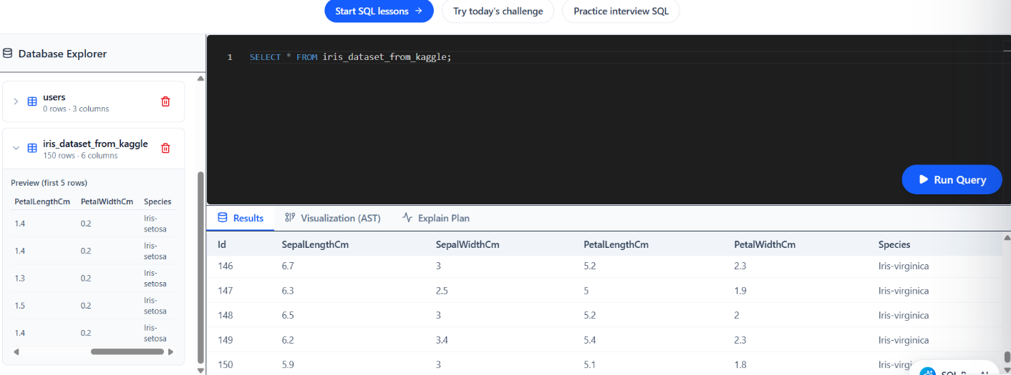
Total Flowers
SELECT COUNT(*) AS Total_Flowers FROM iris_dataset_from_kaggle;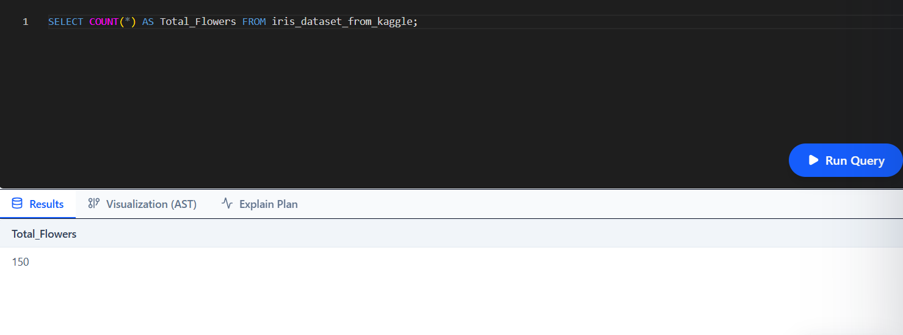Count by Species
SELECT Species, COUNT(*) AS Total FROM iris_dataset_from_kaggle GROUP BY Species;
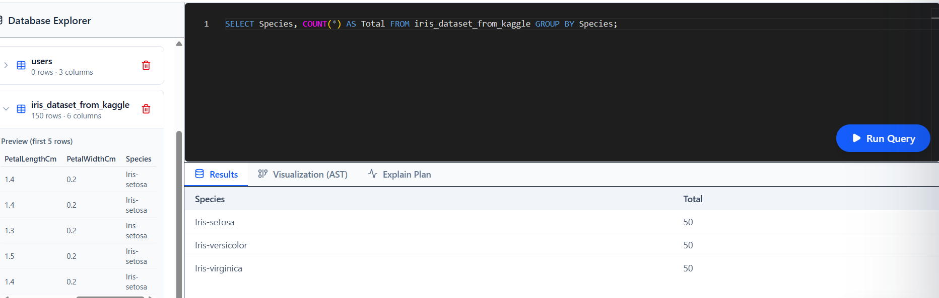
Average Sepal Length
SELECT Species, ROUND(AVG(SepalLengthCm),2) AS Avg_Sepal_Length FROM iris_dataset_from_kaggle GROUP BY Species;
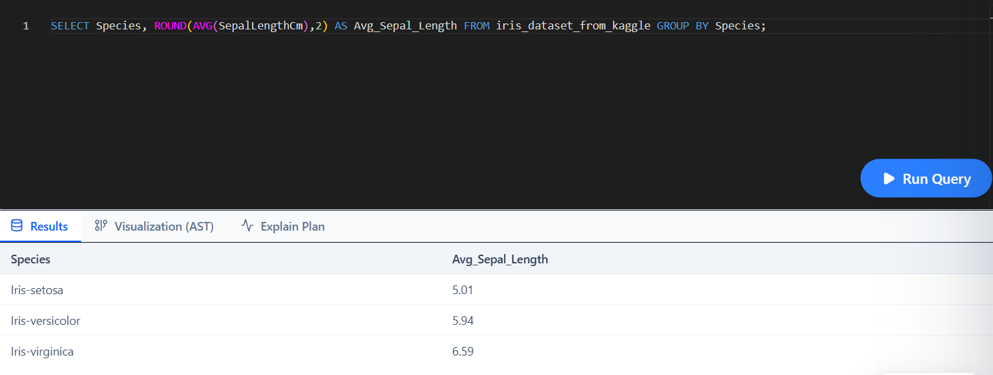
Average Petal Length
SELECT Species, ROUND(AVG(PetalLengthCm),2) AS Avg_Petal_Length FROM iris_dataset_from_kaggle GROUP BY Species;
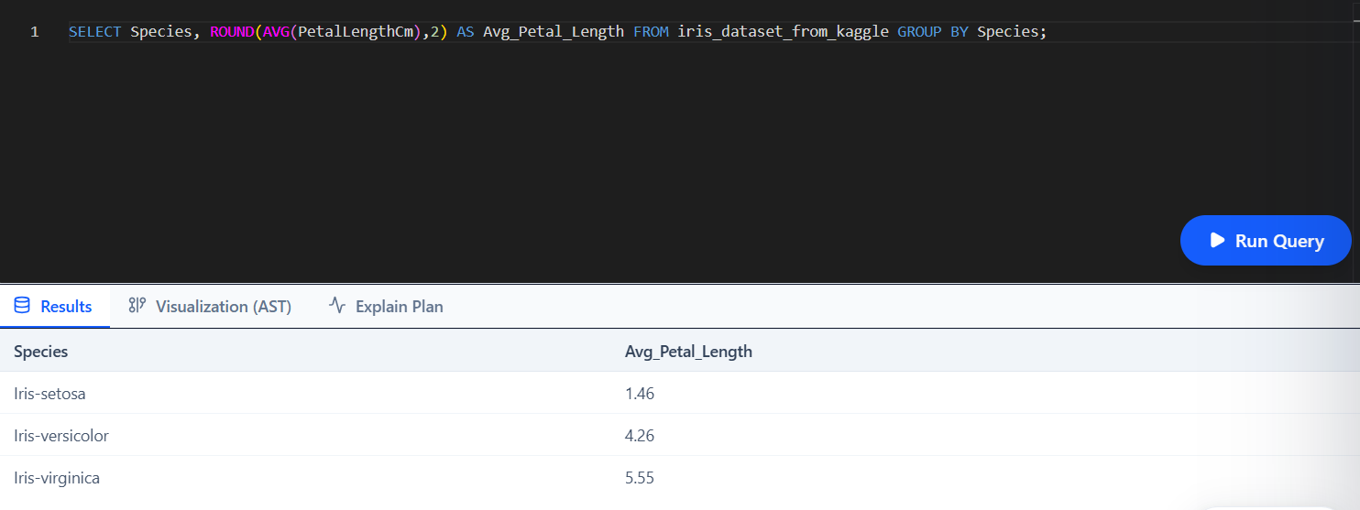

Largest Petal Length
SELECT MAX(PetalLengthCm) AS Largest_Petal FROM iris_dataset_from_kaggle;
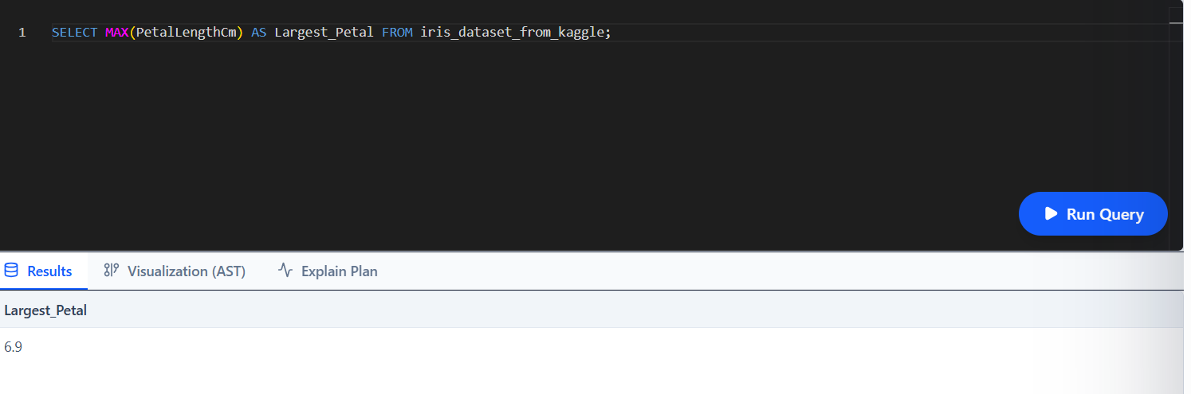
Smallest Sepal Width
SELECT MIN(SepalWidthCm) AS Smallest_Sepal_Width FROM iris_dataset_from_kaggle;
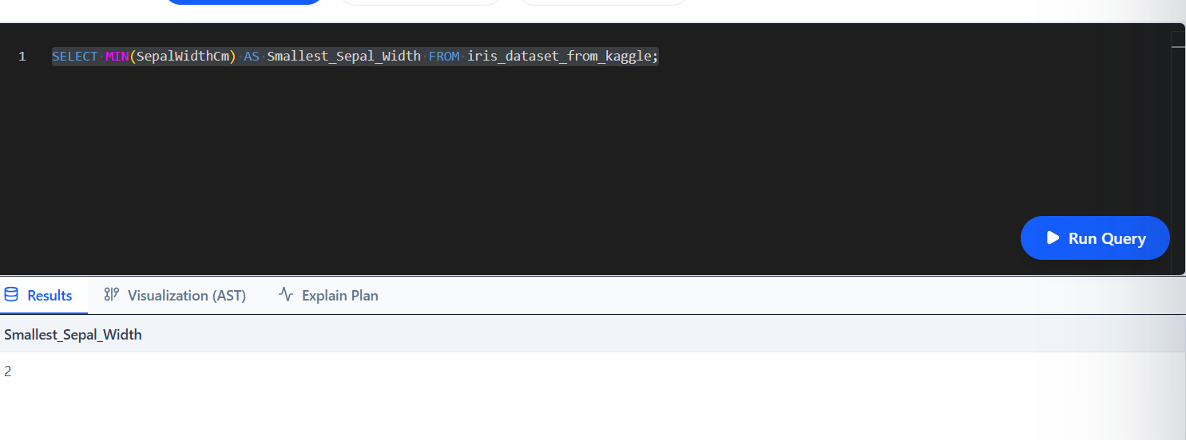
Flowers with Petal Length Greater Than 5 cm
SELECT * FROM iris_dataset_from_kaggle WHERE PetalLengthCm > 5;
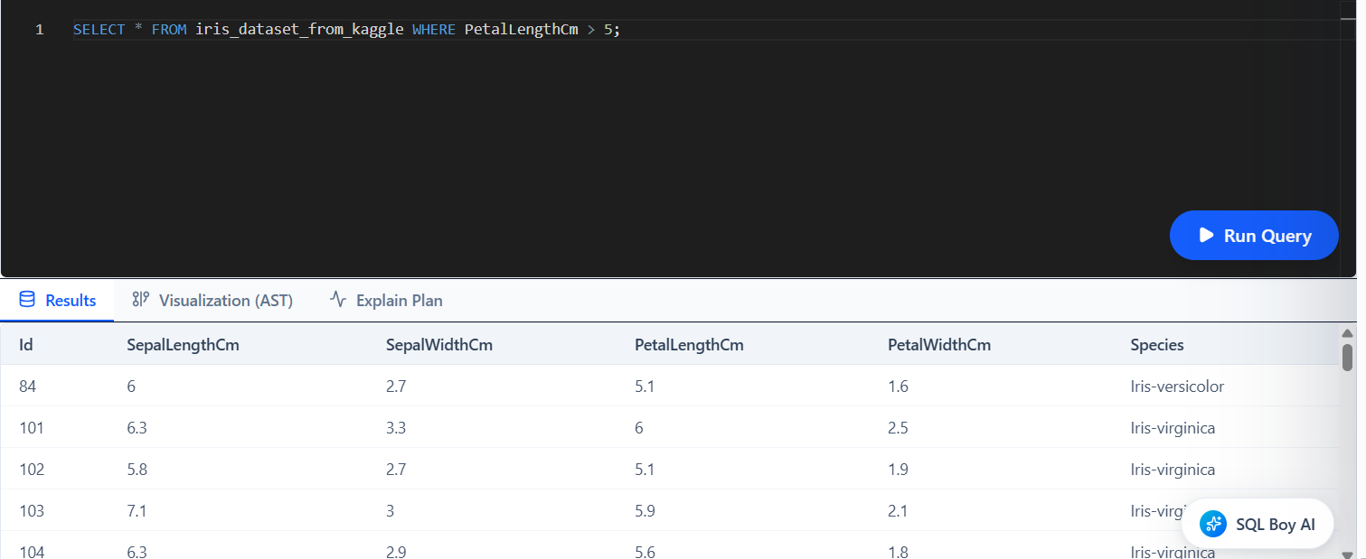
Sort by Sepal Length
Species, SepalLengthCm FROM iris_dataset_from_kaggle ORDER BY SepalLengthCm DESC;
